**Module (HTML5) – 3**

**1) What are the new tags?**

**Ans.**

1) <article>

2) <aside>

3) <audio>

4) <canvas>

5) <command>

6) <details>

7) <embad>

8) <figure>

9) <mark>

10) <math>

11) <nav>

12) <uotput>

13) <svg>

14) <time>

15) <video>

**2) How to embad audio and video in a webpage?**

**Ans.**

1)Add an HTML5 media player to your webpage using the <audio> or <video> tag.

2) Spacify the source of your media file using the src attribute.

3) Add any additional attributes, such as controls, to customize the player’s behavior.

**Input:**

* **Video:** Here’s an example of how embed an MP4 file using the <video> tag:

<!DOCTYPE html>

<html lang="en">

<head>

<meta charset="UTF-8">

<meta http-equiv="X-UA-Compatible" content="IE=edge">

<meta name="viewport" content="width=, initial-scale=1.0">

<title>Document</title>

</head>

<body>

<video src= “big_buck_bunny_720p_1mb.mp4” controls autoplay> </video>

</body>

</html>

**Output:**

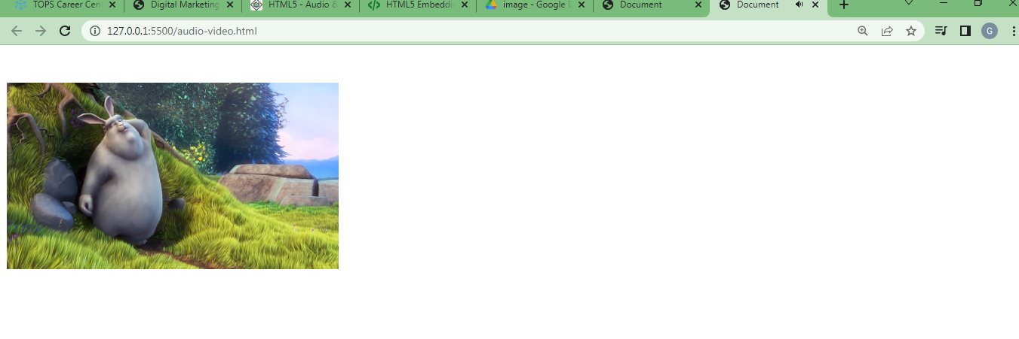

* **AUDIO:** Here’s an example of how embed an MP3 file using the <audio> tag:

**Input:**

<audio src="censor-beep-10sec-8113.mp3" controls loop></audio>

**Ouput:**

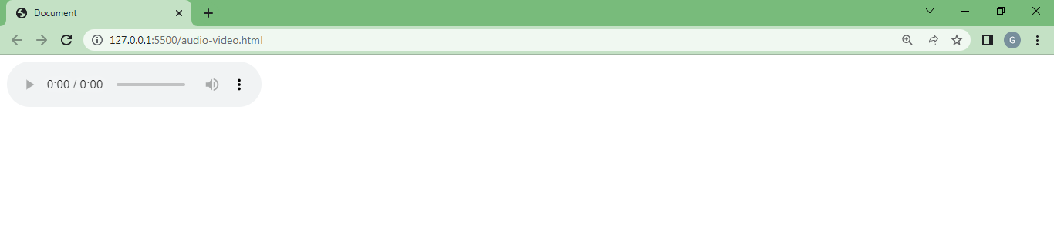

**3) Semantic element in HTML5?**

**Ans.** Semantic elements are HTML5 elements that have a specific meaning and purpose beyond their purely visual appearance. They help to structure a webpage’s content and provide additional information about the page’s content to search engines,screen readers,and other web tehchnologies.

* <header>: Defines a navigation section for a webpage or a section within a webpage.
* <nav>: Defines a navigation section that contains links to other pages or sections within the same page.
* <main>: Defines a main content of a webpage.
* <section>: Defines a section of content within a webpage.
* <article>: Define an independent piece of content such as a blog post or news article.
* <aside>: Defines content that is related to the main content but not necessarily part of it, such as a sidebar or call-out box.
* <footer>: Defines a footer section for a webpage or a section within a webpage. Using semantic elements in your HTML code can make your webpage more accessible and easier to understand for both users and machines.

They can also heip with search engine optimization (SEO) by providing additional context to search engines about your webpage’s content.

4) Canvas and SVG tags

Ans. SVG:

* svg stands for scalable vector graphics
* svg is used to define graphics for the web
* svg is a w3c recomendation

input:

<!DOCTYPE html>

<html lang="en">

<head>

<meta charset="UTF-8">

<meta http-equiv="X-UA-Compatible" content="IE=edge">

<meta name="viewport" content="width=, initial-scale=1.0">

<title>Document</title>

</head>

<body>

<svg width="100" height="100">

<circle cx="50" cy="50" r="40" stroke="blue" stroke-width="4"

fill="yellow" />

</svg>

</body>

</html>

**Output:**

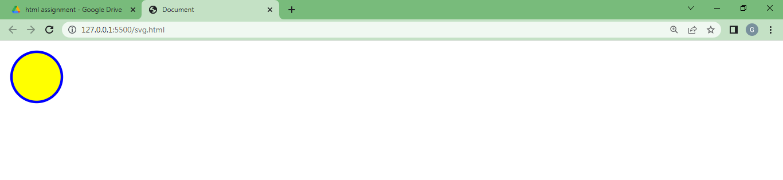

**Canvas:**

The HTML5 canvas element can be used to draw graphics on the webpage via javascript.

Bydefault the <canvas> element has 300px width and 100px of height without any border and content. However, custom width and height. Can be defined using the CSS height and width property whereas the border can be applied using the CSS border property.

**Input:**

<!DOCTYPE html>

<html lang="en">

<head>

<meta charset="UTF-8">

<meta http-equiv="X-UA-Compatible" content="IE=edge">

<meta name="viewport" content="width=device-width, initial-scale=1.0">

<title>Document</title>

</head>

<body>

<canvas id="canvas" height="100" width="300" style="border: 2px solid blue">canvas</canvas>

<script>

var c= document.getElementById("canvas");

var ctx = c.getContext("2d");

ctx.font = " 20px Arial";

ctx.fillText ("Hello World",10,50)

</script>

</body>

</html>

**Output:**

